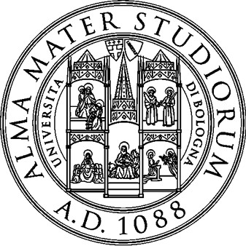

Alma Mater Studiorum- University of Bologna

Faculty of Science

Master degree in

Scienze e gestione della natura
Curriculum
Global change ecology and sustainable development goals

TEA BAGS AND LITTER BAGS FOR STUDYING LITTER DECOMPOSITION IN SEMI-NATURAL AND RESTORED WETLANDS IN DENMARK

CANDIDATE
Paolo Rossi

SUPERVISOR
Alessandro Chiarucci

CO-SUPERVISORS
Hans Henrik Bruun Marta Baumane Lars Baastrup-Spohr

IV session Academic year 2022/2023

