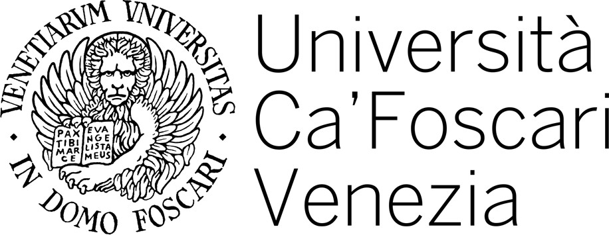

Master 's degree programme in Global Development and Entrepreneurship

FINAL THESIS

Unveiling the High-Tech Cluster Phenomenon in Israel: Exploring the Dynamics of Globalization and Innovation

Supervisor:
Ch. Prof. Giancarlo Corò

Graduand: Rossi Paolo
Matriculation Number 975931

Academic Year: 2022/2023

